Database Management System

Version 1.0

Revision History

|  |  |  |  |
| --- | --- | --- | --- |
| **Date** | **Version** | **Description** | **Author** |
| 08/12/2021 | 1.0 | Initial release | Do Minh Vuong |
|  |  |  |  |
|  |  |  |  |
|  |  |  |  |

Table of Contents

1. Introduction 4

1.1 Purpose 4

1.2 Scope 4

1.3 Definitions, Acronyms, and Abbreviations 4

1.4 References 4

1.5 Overview 4

2. Flow of Events—Design 4

2.1 Sequence diagram 4

2.2 Class diagram 6

3. Derived Requirements 6

# Introduction

This document is the design document for Remote Database Management use-case.

## Purpose

The purpose of this document is to give offer design solution for Remote Database Management use-case. Classes are specified and each class method is defined in terms of parameters and purpose.

This document should give enough information that use case implementation is possible.

## Scope

The use case realization specification covers:

* class diagram
* sequence diagram

## Definitions, Acronyms, and Abbreviations

Nothing needs to be defined.

## References

This document is based on: Remote Database Management Use Case

## Overview

This use-case describes how the web administrator manage all of access hosts to the database service server.

# Flow of Events—Design

## Sequence diagram

### Add a new access host

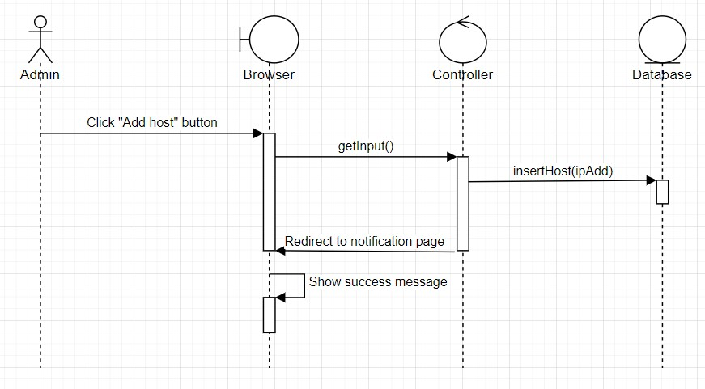

### Update an access host comment

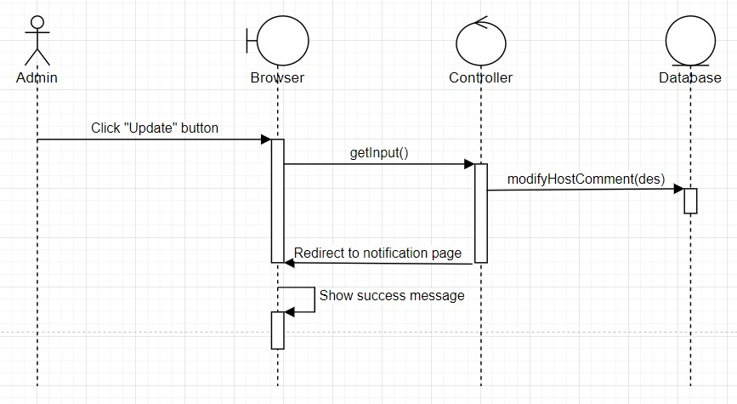

### Delete an access host

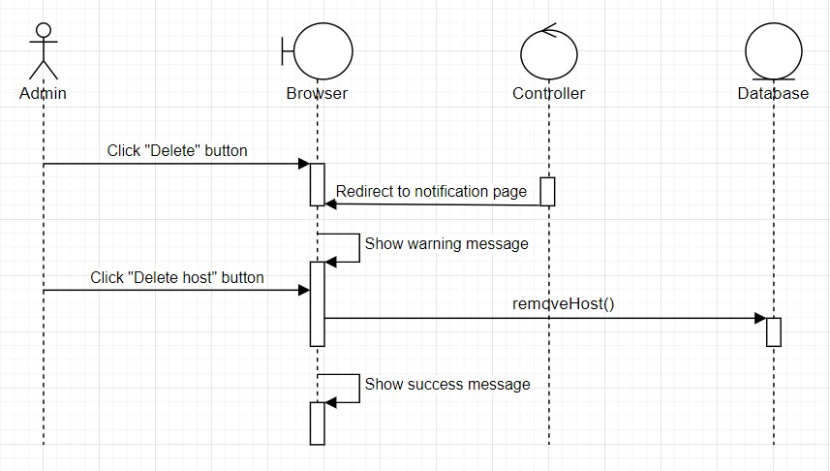

## Class diagram

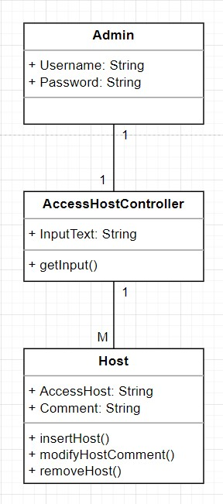

# Derived Requirements

There are no derived associated with this use-case-realization.